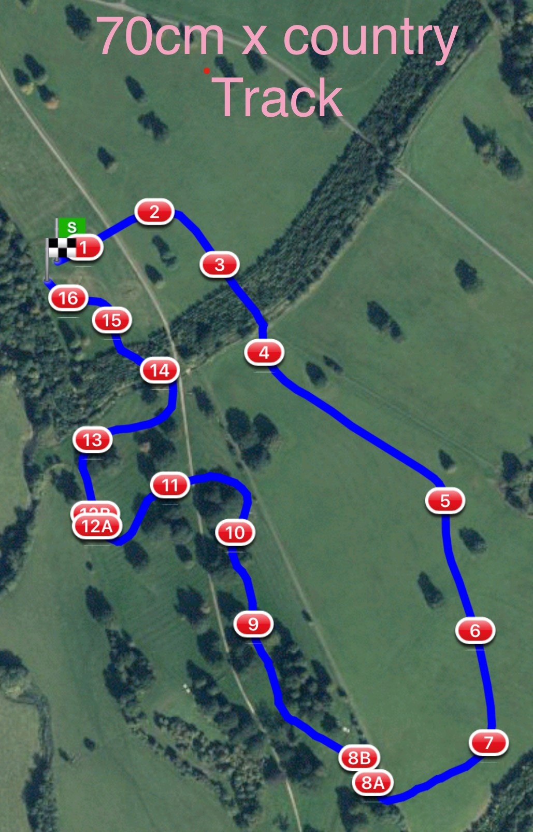

70cm Track Pink Discs 1988m

1 LandS Eventing Log 10. Scary Black Pipe
2 Farriers Fayre Pheasant Feeder 11. Bill Roses Log
3 Picnic Table 12.ab The National Saddle Centre
4 Sleeper Flower Trough Water Splash
5 The Muffin Mans Bakery 13. Gymima Barge
6 Tanks For All Your Support in 2021 14. Sunken Road Palisade
7 Dog Kennel 15. Flocking Big Brush
8ab RF Veterinary Physio Therapy Question 16. #welovevolunteers final flyer
9 Millers Lorry Cart

