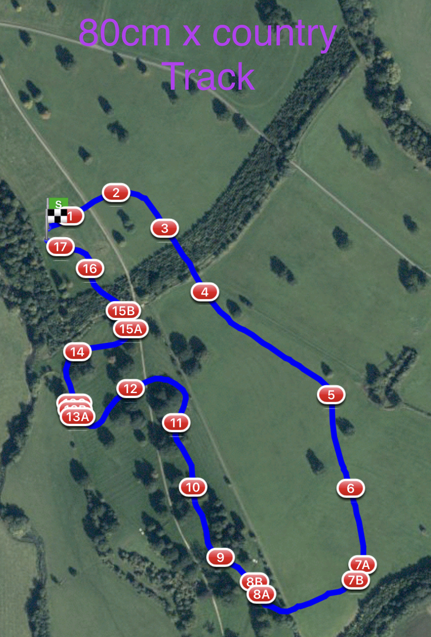

80cm purple discs distance 1999m

1 LandS Eventing Log 10. Miller’s Lorry Cart
2 Farriers Fayre Pheasant Feeder 11. Warwickshire Hire Tables
3 Picnic Table 12. Bill Roses Bush
4 Sleeper Flower Trough 13abc The National Saddle Centre
5 The Muffin Mans Bakery Water Splash
6 Tanks For All Your Support In 2021 14. Gymima Barge
7ab Dog Kennel Double 15ab Sunken Road
8ab RF Veterinary Physio Therapy Question 16 Flocking Big Brush
9 Beewear Log 17. #welovevolunteers Final Flyer

