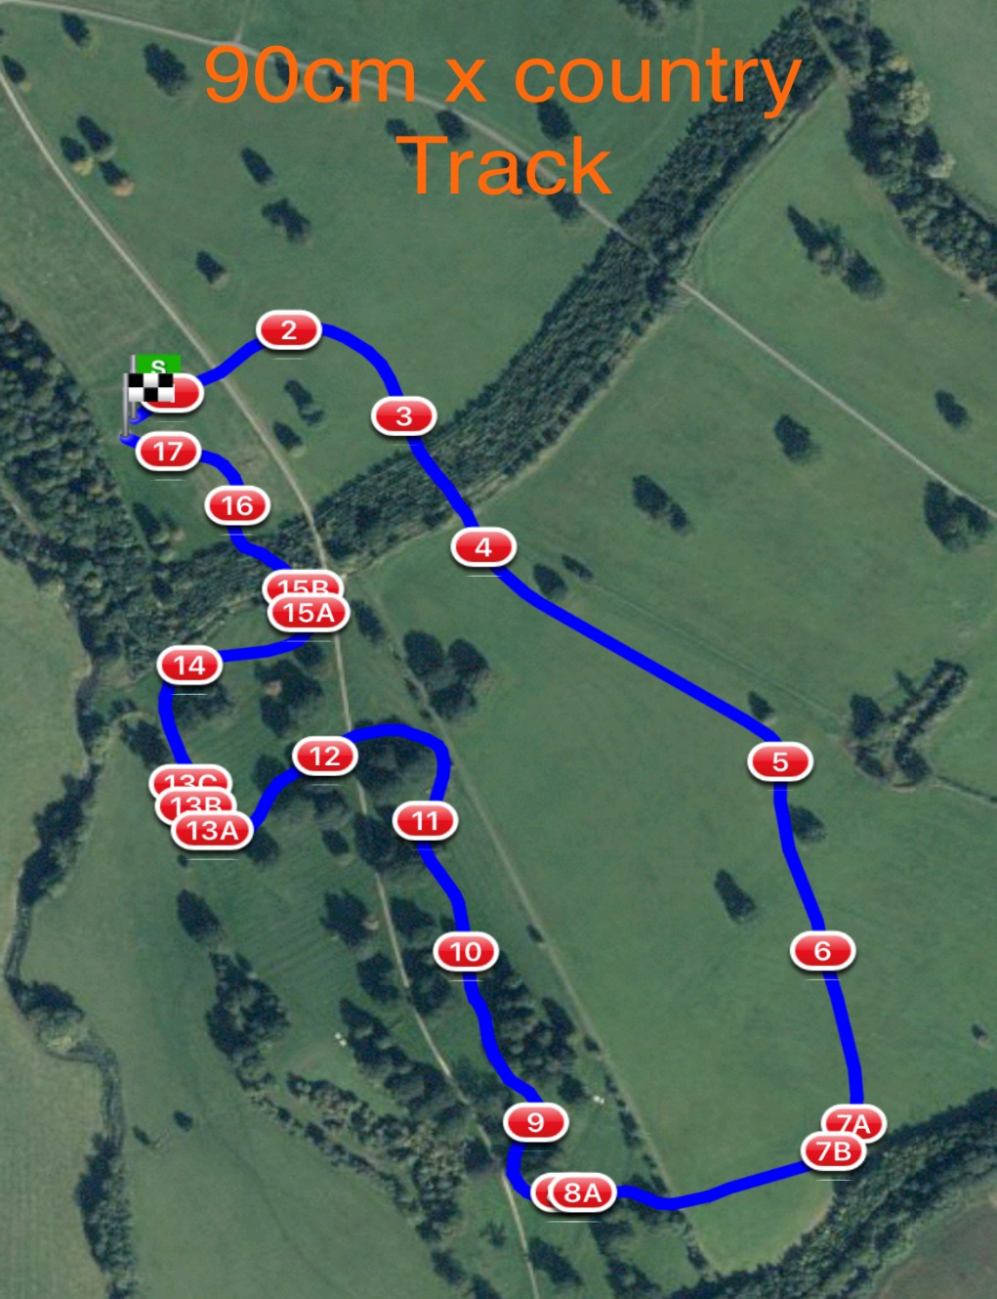

Orange discs 90cm distance 2094mtr

1 LandS Eventing Log 10. Millers Lorry Cart
2 Farriers Fayre Pheasant Feeder 11. Warwickshire Hire Tables
3 Picnic Table 12. Bill Roses Brush
4 Sleeper Flower Trough 13.abc The National Saddle Centre
5 The Muffin Mans Bakery Water Splash
6 Tanks For All Your Support In 2021 14. Gymima Barge
7ab Dog Kennel Double 15ab Sunken Road
8ab RF Veterinary Physio Therapy Question 16. Flocking Big Brush
9 Beewear Ditch 17. #welovevolunteers Final Flyer

