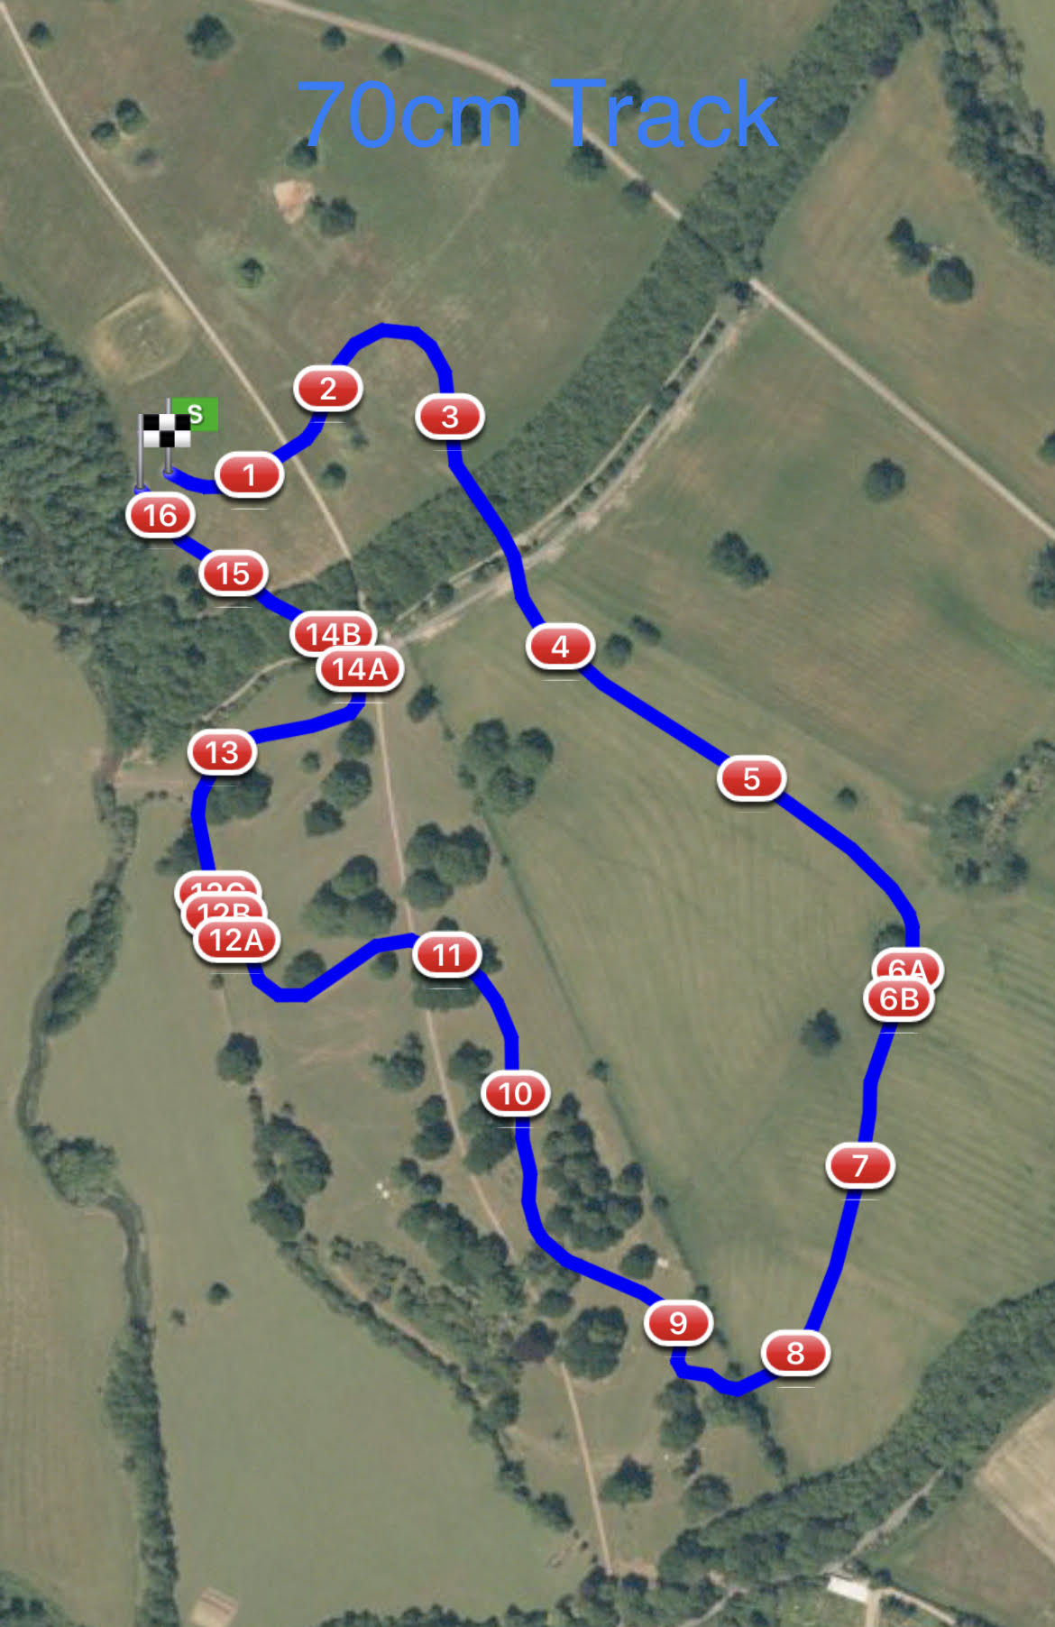

1 LandS Eventing Log  2 AvonVale Feeders

3 Bury Blue House 4 DMA Sleeper Trough

5 Warwickshire Hire Tables  6ab RF Veterinary Physio Farm Yard

7 The National Saddle Centre Table  8 Oh Deer Feeder

9 Bill Rose’s Bush  10 Gymima Work Out Palisade

11 LandS Lads Log  12abc Josh and Charley Peake

 Construction Water Splash

13 1st Class Barges  14ab Flocking Black Pipes

15ab Dog Kennel   16 #Welovevolunteersfinalflyer