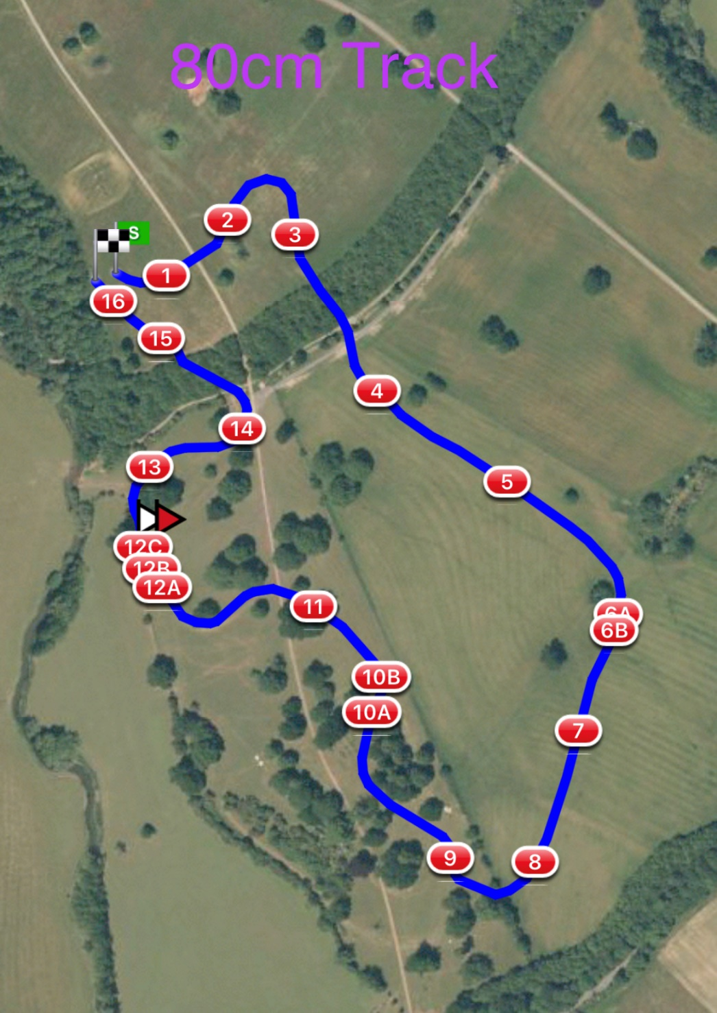

1 LandS Eventing Log 2 Avon Vale Feeders
3 Bury Blue House 4 DMA Sleeper Trough
5 Warwickshire Hire Tables 6ab RF Veterinary Physio Farm Yard
7 The National Saddle Centre Table 8 Oh Deer Feeder
9 Bill Rose’s Bush 10ab Gymima Work Out Double
11 LandS Lads Log 12abc Josh and Charley Peake Construction Water Splash
13 1st Class Barges 14 Flocking Skinny Boat
15 Dog Kennel 16 #Welovevolunteersfinalflyer

