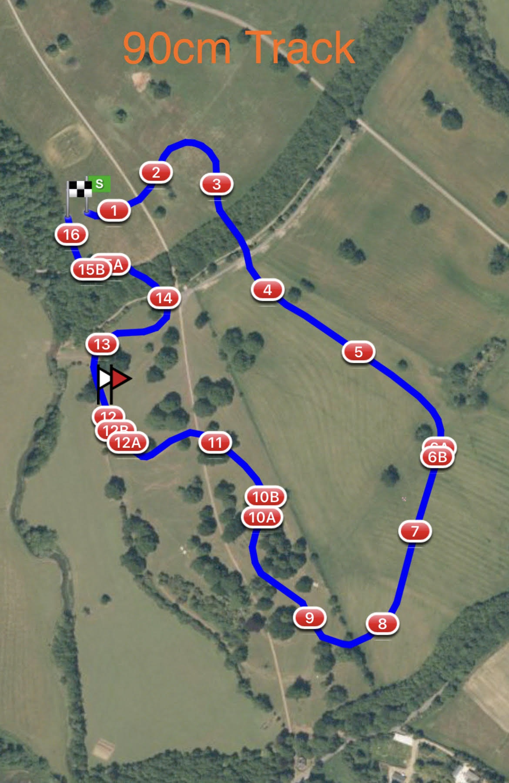

1 LandS Eventing Log 2 AvonVale Feeders
3 Bury Blue House 4 DMA Sleeper Trough
5 Warwickshire Hire Tables 6ab RF Veterinary Physio Farm Yard
7 The National Saddle Centre Table 8 Oh Deer Feeder
9 Bill Roses Bush 10ab Gymima Work Out Double
11 LandS Lads Log 12abc Josh and Charley Peake Water Splash
13 1st Class Barges 14 Flocking Big Ditch
15ab Dog kennel Corner 16 #Welovevolunteersfinalflyer

